Remote Access to Dominican Server acats2k12.dom.edu from a PC. Version 2: July 10,2019
Please send comments and change requests to me at Jim Miller jmiller@dom.edu.

Major Steps
- Start Microsoft Remote Desktop Connection
- Define Basic Information
- Define Advanced Information (required for off-campus)
- Save your configuration
- Close Microsoft Remote Desktop Connection
- Use your saved configuration (double click on your saved file) to access the Dominican Server acatsnew.dom.edu.
- Begin working just as if you were at the keyboard of the machine acatsnew.dom.edu

Details NOTE COMPUTER NAME HAS CHANGED AND GRAPHIC IS OUT-OF-DATE. Use the new name acats2k12.dom.edu

Start Microsoft Remote Desktop Connection
1a. Search your PC using “remote desktop”
1b. Start the program Remote Desktop Connection.
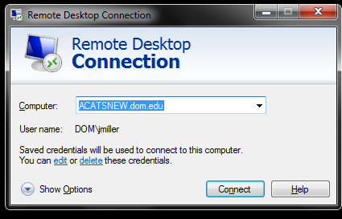

Define Basic Information
2a Enter the Computer (acats2k12.dom.edu) and your username (dom\username)

Define Advanced Information
3a. Click on “Show Options”
3b. Click on the Advanced Tab
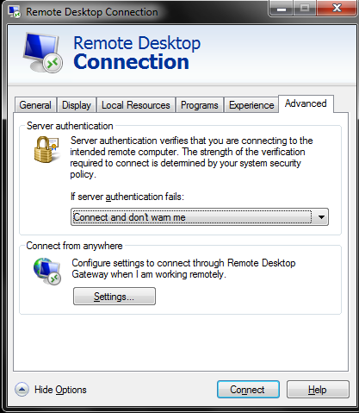
3c. Click on Settings
3d. Specify options as shown in the next screen:
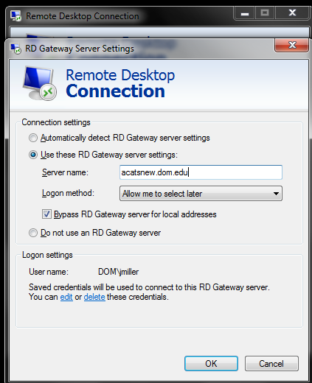

- Save Your Configuration.
  - Click the General Tab
  - Click Save as and save your small file where you can find it later. (See screen shot at end of document)
- Close Remote Desktop Connection.
- Double Click on the file you just saved to connect to acatsnew.dom.edu.

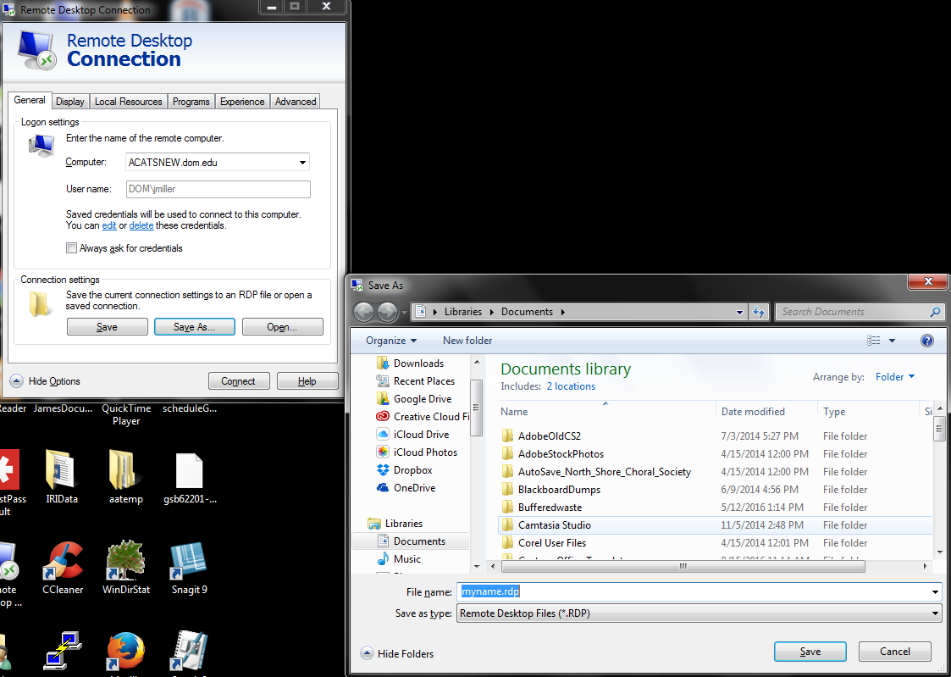

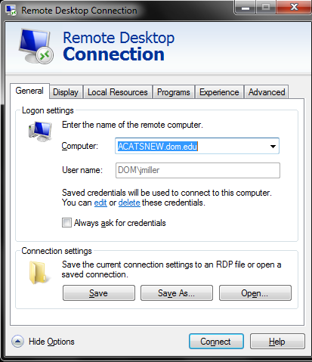
ABOVE FIGURE IS OUT-OF-DATE. The computer name is acats2k12.dom.edu

